**Name: Kanak Agrawal**

**Day-6 Assignment**

**Question:** Over and Partition by clause in sql

**Answer:**

**Query:** SELECT

car_make,

car_model,

car_price,

AVG(car_price) OVER() AS "overall average price",

AVG(car_price) OVER (PARTITION BY car_type) AS "car type average price"

FROM car_list_price;

**Output:**

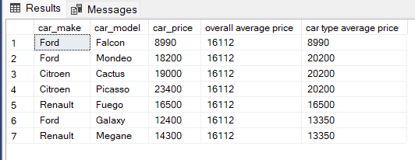

**Question:** Total Aggregation using over and partition by in sql Queries

**Answer:**

* **SUM**

**Query:** select

car_make, car_model ,car_price,

Sum(car_price) over() As "Total Salary"

from car_list_price;

**Output:**

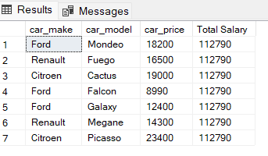

* **GROUP BY**

**Query:** select

car_make,

sum(car_price) AS total_salary

from car_list_price

group by car_make;

**Output:**

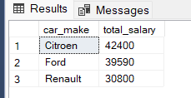

* **AVERAGE**

**Query:** SELECT

car_make,

car_model,

car_price,

AVG(car_price) OVER() AS "overall average price",

AVG(car_price) OVER (PARTITION BY car_type) AS "car type average price"

FROM car_list_price;

**Output:**



**Question:** snowflaking& Star schemas

**Answer:**

* **SNOWFLAKE**

**Query:** create database snowflake;

use snowflake;

create table salestable

(

product_id int not null primary key,

order_id int not null,

customer_id int not null,

employeer_id int not null,

total int not null ,

Quantity int not null,

discount int );

create table time_dimension

(

order_id int not null primary key,

order_date date not null);

create table customer_dimension

(customer_id int not null primary key,

city_id int not null,

customer_name char(30) not null,

address varchar(50) not null,

city char(25) not null,

zip int not null);

create table product_dimension

(

product_id int not null primary key,

Product_name varchar(50) not null ,

product_prize decimal not null);

create table emp_dimension

(employeer_id int not null primary key,

emp_name varchar(30) not null,

department varchar(25) not null,

department_id int not null);

create table city_dimension

(city_id int not null primary key,

city_name char(30) not null,

state char(25), country char(20)

);

create table Product_category_dimension

(product_id int not null primary key,

name varchar(50) not null,

pro_description varchar(50) not null,

unit_prize int not null

FOREIGN KEY (product_id) REFERENCES product_dimension(product_id));

create table department_dimension

(department_id int,

department varchar(25) not null,

location varchar(25) not null);

select * from salestable;

select * from time_dimension;

select * from customer_dimension;

select * from product_dimension;

select * from emp_dimension;

select * from city_dimension;

select * from Product_category_dimension;

select * from department_dimension;

**Output:**

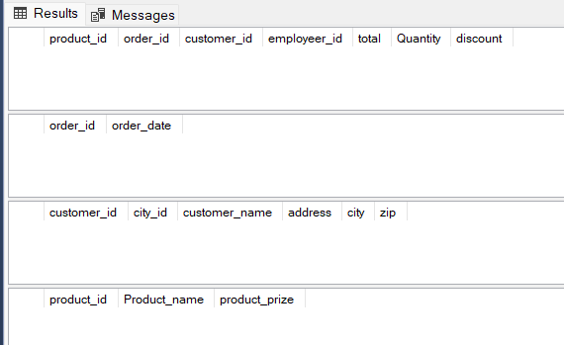

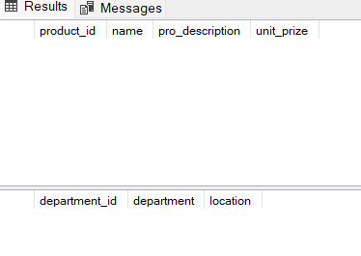

**Question:** How to calculate Subtotals in SQL Queries.

**Answer:**

**Query:** SELECT CASE

WHEN GROUPING(SalesQuartes)=1 AND GROUPING(SalesYear)=0

THEN 'SubTotal'

WHEN GROUPING(SalesQuartes)=1 AND GROUPING(SalesYear)=1

THEN 'Grand Total'

ELSE

CAST(SalesYear AS varchar(10))

END AS SalesYear,

SalesQuartes,

SUM(SalesTotal) AS SalesTotal

FROM SalesList

GROUP BY ROLLUP(SalesYear,SalesQuartes);

**Output:**

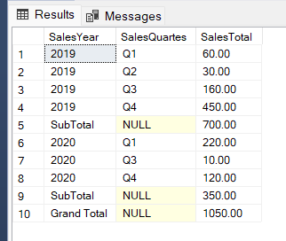

**Question:** Differences Between UNION EXCEPT and INTERSECT Operators in SQL Server.

**Answer:**

* **UNION**

**Query:** select * from sensor_1

UNION All

select * from sensor_2;

**Output:**

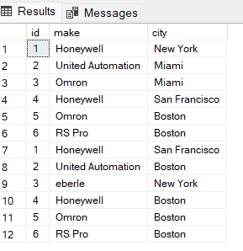

* **EXCEPT**

**Query:**

select * from sensor_1

Except

select * from sensor_2;

**Output:**

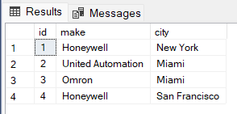

* **INTERSECT**

**Query:** select * from sensor_1

Intersect

select * from sensor_2;

**Output:**

